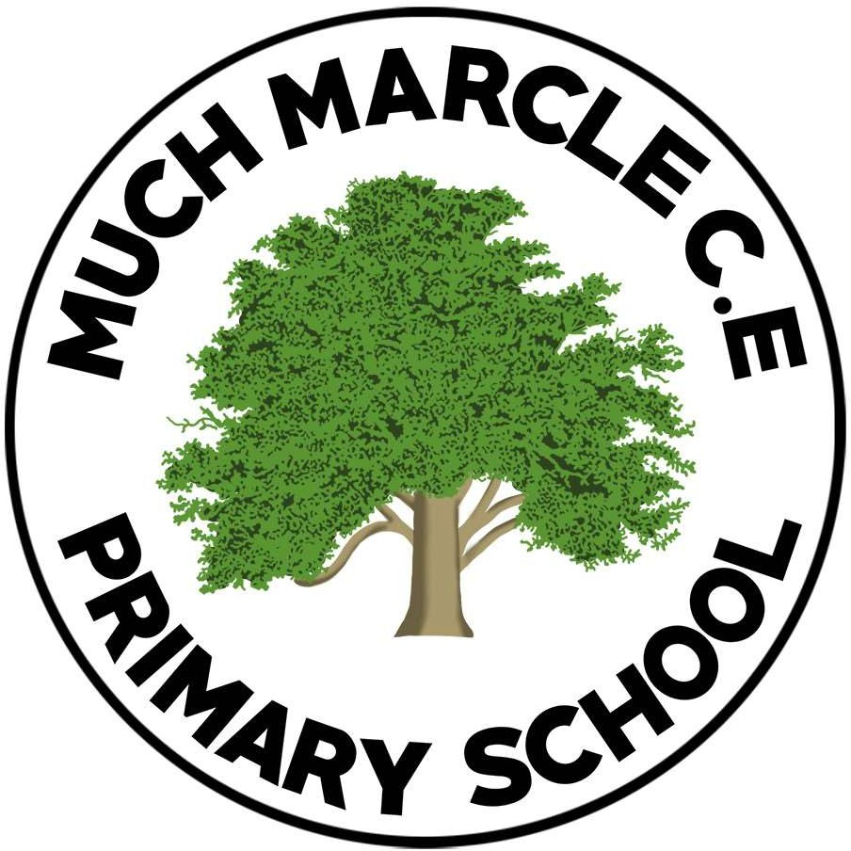

Admissions Policy 2025-2026

Written | Consultation Period | Review Date
November 2022 | December 19th – January 30th 2023 | September 2023  September 2024  September 2025

Introduction

The purpose of this policy is to set out in clear terms, Much Marcle CE Primary’s procedures regarding admission of pupils, ensuring a smooth and trouble free transition from pre-school to the primary school.

Planned Admission number

Our Planned Admission Number (PAN) for the Reception Year is 17.

Age of Admission

Parents and carers are not obliged to take up places for their children any earlier than the law requires (i.e. currently from the term following their fifth birthday.) However, in Herefordshire most children start school at least a term earlier than the law requires. Children who become five in the Autumn term (between 1st September and 31st December) will attend school full time. Children who turn 5 in the spring term (1st January – 30th April) or summer term (1st May – 31st August) will be invited to attend school full time. Parents and carers are encouraged to send their children to school full time, from the beginning of the Autumn term. Once a place has been allocated, parents and carers have the right to choose the start time they feel appropriate for their child. It is advised to discuss this with the Head teacher prior to application. Schools cannot require children to start sooner than parents and carers wish.

Application Process

We encourage parents and carers to visit Much Marcle before submitting their application.
Parents (i) and carers wishing to apply for the Reception Year in September must complete the common online application made through the local authority in whose area you live at the time of application. The online application must be submitted to that local authority no later than 15th January. Applications received after this date will normally only be considered after all those received on or before the cut-off date. Herefordshire local authority will post offers and refusals of places on the published ‘National Offer Day’.

Over-subscription criteria

Children with an Education, Health and Care (EHCP) plan, which names the school will be admitted.

- 'Looked after children' (ii) defined by the school’s admissions code and those as being ‘previously looked after children’
- Children with a normal home address(iii) in the catchment and with a sibling(v) on the roll of the school or the nursery at the time of application or whose parent or carer has accepted an offer of a place at the school and who is expected still to be in attendance at the time of entry
- Children with a normal home address in the catchment area

- Children with a normal home address outside the catchment area and with a sibling on the roll of the school or the nursery at the time of application or whose parent have accepted an offer of a place at the school and who is expected still to be in attendance at the time of entry to the school

All Other Admissions

Admission to the school during the academic year depends on whether or not there are places available. Applications may be made to the school in the first instance.

Admission outside normal age group
Requests from parents and carers for places outside a normal age group will be considered carefully e.g. for those who have missed education due to ill health. Each case will be considered on its own merits and circumstances.

Appeals- Arrangements for appeals panels

The arrangements for Appeals will be in line with the School Admission Appeals Code published by the Department for Education (DFE), which means that parents will have 20 school days from national offer day in which to submit an appeal. Appeal hearings will be held within 40 schools days of the deadline for the lodging of appeals. The determination of the appeal panel will be made in accordance with the School Admission Appeals Code and is binding on all parties.

The school will provide guidance for parents and carers about how the appeals process will work and will provide parents with a named contact who can answer any enquiries they may have about the process.

Review of Procedures

All procedures for admission are reviewed annually by the school in consultation with staff and the full governing body.

Appendix to the Admissions Policy

  - “Parent” is defined in law (The Education Act 1996) as either:
    - any person who has ‘parental responsibility’ (defined in the Children Act 1989) for the child or young person; or
    - any person who has care of the child or young person.
If you are in any doubt, please contact the school for advice.

  - A looked after child who is (a) in the care of the local authority or (b) being provided with accommodation by a local authority in the exercise of their social services functions (see the definition in Section 22(1) of the Children Act 1989) 1 An adoption order is an order under the Adoption Act 1976 (see Section 12 adoption orders) and children who were adopted under the Adoption and Children Act 2002 (see Section 46 adoption orders). A ‘child arrangements order’ is an order settling the arrangements to be made as to the person with whom the child is to live under Section 8 of the Children Act 1989 as amended by Section 14 of the Children and Families Act 2014. Section 14A of the Children Act 1989 defines a ‘special guardianship order’ as an order appointing one or more individuals to be a child’s special guardian (or special guardians)

  - By normal home address, we mean the child’s home address. This must be where the parent or legal carer of the child lives with the child unless it is proved that the child is resident elsewhere with someone else who has legal care and control of the child. The address should be a residential property that is owned, leased or rented by the child’s parent/s or person with legal care and control of the child. (The school may ask for evidence dated within the last 3 months showing that you live at this address.)
If parents are moving house, the school will ask for evidence of the move, before considering any application for a place.

Where a child lives with parents with shared responsibility, each for part of a week or month, the address where the child lives will be determined having regard to a joint declaration from the parents stating the exact pattern of residence.

  - Catchment areas are defined by the local authority and can be found on https://www.herefordshire.gov.uk/schools-education/schools-catchment-map

  - By sibling we mean a brother or sister, half brother or sister, adopted brother or sister, step brother or sister, or the child of the parent’s/carer’s partner where the child for whom the school place is sought is living in the same family unit at the same address as that sibling. It is helpful if parents make it clear on the application form where the sibling has a different family name. Where there is more than one sibling at the school, only the youngest should be listed on the application form.

