Low-Level Concerns Policy 2025



This policy is to be read alongside the following documents:
- KCSIE 2025 Keeping Children Safe in Education (DfE September 2025)
- KCSIE Part 1 and Annex for Further Information
- Working Together to Safeguard Children (DfE 2024)
- Information Sharing (HM Govt July 2018)
- The procedures of Herefordshire Safeguarding Children Partnership https://herefordshiresafeguardingboards.org.uk/
- Staff Code of Conduct Policy
- Behaviour Policy

Low-level concerns

Much Marcle Primary promotes a whole school approach to safeguarding, ensuring an open and transparent culture in which all concerns about all adults working in or on behalf of the school (including supply teachers, volunteers and contractors) are dealt with promptly and appropriately.
All concerns about adults (including allegations that do not meet the harms threshold (see KCSIE 2025 Part Four - Section one) are shared responsibly and with the right person, they are recorded and dealt with appropriately. This will encourage an open and transparent culture; enable school to identify concerning, problematic or inappropriate behaviour early; minimise the risk of abuse; and ensure that adults working in or on behalf of the school are clear about professional boundaries and act within these boundaries, and in accordance with the ethos and values of the school.

What is a low-level concern?

The term ‘low-level’ concern does not mean that it is insignificant, it means that the behaviour towards a child does not meet the threshold set out at paragraph 348 KCSIE 2025. A low-level concern is any concern – no matter how small, and even if no more than causing a sense of unease or a ‘nagging doubt’ - that an adult working in or on behalf of the school or college may have acted in a way that:
- is inconsistent with the staff code of conduct, including inappropriate conduct outside of work; and
- does not meet the allegations threshold or is otherwise not considered serious enough to consider a referral to the LADO.
Examples of such behaviour could include, but are not limited to:
- being over friendly with children;
- having favourites;
- taking photographs of children on their mobile phone;
- engaging with a child on a one-to-one basis in a secluded area or behind a closed door; or,
- using inappropriate sexualised, intimidating or offensive language.

Such behaviour can exist on a wide spectrum, from the inadvertent or thoughtless, or behaviour that may look to be inappropriate, but might not be in specific circumstances, through to that which is ultimately intended to enable abuse.

KCSIE 2025 Para 427 highlights that low-level concerns may arise in several ways and from a number of sources. suspicion; complaint; or disclosure made by a child, parent or other adult within or outside of the organisation; or as a result of vetting checks undertaken.

It is crucial that any such concerns, including those which do not meet the harm threshold (see KCSIE 2025 Part Four - Section two), are shared responsibly and with the right person, and recorded and dealt with appropriately. Ensuring they are dealt with effectively should also protect those working in or on behalf of the school from potential false allegations or misunderstandings.

Reports of any low-level concern from pupils or staff should be made in the first instance to the Headteacher, or in their absence Deputy Head. If the issue relates to the Headteacher, the information is to be given to the Chair of Governors via email or by phone with the telephone number held in the school office.

Staff code of conduct and safeguarding policies

This low-level concerns policy sits alongside the Staff Behaviour (Code of Conduct Policy) 2022/2025 and the 2025 Safeguarding and Child Protection Policy. It is important to share low-level concerns for the purpose of creating and embedding a culture of openness, trust and transparency in which the school’s values and expected behaviour are constantly lived, monitored and reinforced by all staff.
The governing body ensures the staff code of conduct, behaviour policies and safeguarding policies and procedures are implemented effectively, and ensure appropriate action is taken in a timely manner to safeguard children and facilitate a whole school approach to dealing with any concerns.

Much Marcle aim to achieve the purpose of the low-level concerns policy by:
- ensuring staff are clear about what appropriate behaviour is, and are confident in distinguishing expected and appropriate behaviour from concerning, problematic or inappropriate behaviour, in themselves and others;
- empowering staff to share any low-level safeguarding concerns as per paragraph 432 KCSIE 2024;
- addressing unprofessional behaviour and supporting the individual to correct it at an early stage;
- providing a responsive, sensitive and proportionate handling of such concerns when they are raised; and,
- helping identify any weakness in the school’s safeguarding system

Sharing low-level concerns

Low-level concerns about a member of staff, supply staff, volunteer or contractor should be reported as per paragraph 432 KCSIE 2025. Please see Appendix 1 for Reporting Low Level Concerns. Reports about supply staff and contractors should be notified to their employers, so any potential patterns of inappropriate behaviour can be identified. Our school will ensure there is an environment where staff are encouraged and feel confident to self-refer, where, for example, they have found themselves in a situation which could be misinterpreted, might appear compromising to others, and/or on reflection they believe they have behaved in such a way that they consider falls below the expected professional standards.

Recording low-level concerns see Appendix 1 Reporting Low Level Concerns

All low-level concerns should be recorded in writing. The record should include details of the concern, the context in which the concern arose, and action taken. The name of the individual sharing their concerns should also be noted, if the individual wishes to remain anonymous then that should be respected as far as reasonably possible.

The Headteacher will keep these written records. The record will be confidential, held securely and comply with the Data Protection Act 2018 and the UK General Data Protection Regulation (UK GDPR) (see paragraph 109 for more information).

Records will be reviewed so that potential patterns of concerning, problematic or inappropriate behaviour can be identified. Where a pattern of such behaviour is identified, the school will decide on a course of action, either through its disciplinary procedures or where a pattern of behaviour moves from a concern to meeting the harms threshold, in which case it should be referred to the LADO. Consideration will be given to whether there are wider cultural issues within the school that enabled the behaviour to occur and where appropriate policies could be revised or extra training delivered to minimise the risk of it happening again.

The school will retain the information until the individual leaves the school’s employment.

References

Part three of KCSIE 2025 is clear that the schools will only provide substantiated safeguarding allegations in references. Low level concerns should not be included in references unless they relate to issues which would normally be included in a reference, for example, misconduct or poor performance. It follows that a low-level concern which relates exclusively to safeguarding (and not to misconduct or poor performance) should not be referred to in a reference. However, where a low-level concern (or group of concerns) has met the threshold for referral to the LADO and found to be substantiated, it should be referred to in a reference.

Responding to low-level concerns

On receiving information regarding a low-level concern, the person raising the concern will be asked to complete the form on MyConcern.’ The Headteacher will discuss the concerns raised with the person completing the report and the actions around the concern. The information collected will help the Headteacher to categorise the type of behaviour and determine what further action may need to be taken. All of this will be recorded along with the rationale for the decisions and action taken.
If the concern has been raised via a third party, the Headteacher will collect as much evidence as possible by speaking:
- directly to the person who raised the concern, unless it has been raised anonymously;
- to the individual involved and any witnesses.

The information collected will help them to categorise the type of behaviour and determine what further action may need to be taken. All of this needs to be recorded along with the rationale for their decisions and action taken.
This low-level concerns policy will be a reflection and extension of the school’s wider staff behaviour policy/code of conduct.

Clarity around Allegation vs Low-Level Concern vs Appropriate Conduct
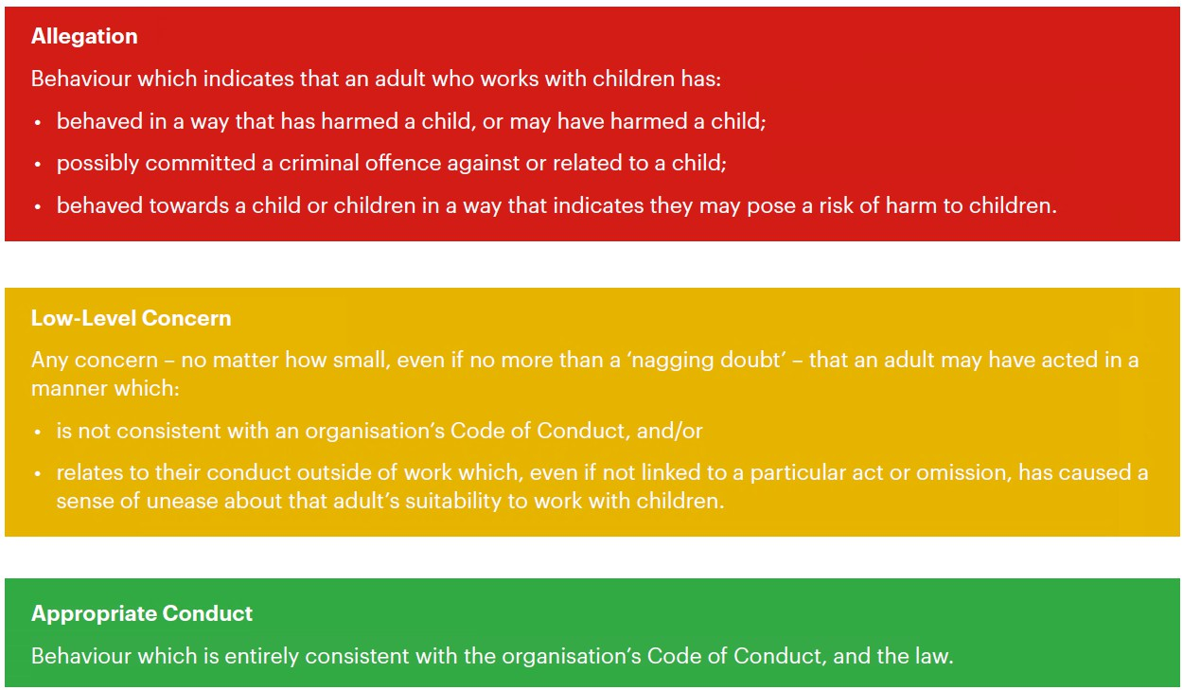

To be reviewed - September 2026

