Attendance and Punctuality Policy


Last reviewed on: | September 2025
Next review due by: | September 2026

Introduction
The Governors and staff at Much Marcle CE Primary School are united in their belief that regular school attendance is the key to enabling children to maximise the educational opportunities available to them. Helping them to become emotionally resilient, confident and competent adults who are able to realise their full potential and make a positive contribution to their community.
Much Marcle CE Primary School values all children. As set out in this policy we will work with families to identify the barriers to achieving and maintaining excellent attendance and offer the right service at the right time to try to resolve any difficulties.
The Headteacher and Business Manager will monitor attendance and use attendance data to identify any patterns of concern, whilst also celebrating success! Attendance concerns will be raised with parents if reasons are not known by the school, e.g. a long period of illness, this information may be shared with the Local Authority following concerns. Where we have concerns, or lack of engagement from families to improve attendance, we will follow the schools escalated approach to improving attendance. The schools escalated approach is child-centred and prioritises support and developing strong working relationships with families. We will use the early help process to provide support prior to escalation and consider how we can work with families to enable your child to access their right to education.

Our aim is to always to work in partnership with parents and any referral for consideration of a penalty notice is deemed to be a last resort at Much Marcle. Attendance figures for each child will be reported to parents as part of the annual report. We will also share a child’s attendance profile if we have concerns regarding a child’s attendance. Throughout the school year the Attendance Team will report on the overall attendance figures for groups of children, this will be closely monitored for support and reported to the Governing Body.

To support good attendance, and safeguarding, at Much Marcle we:

- Ensure the school is welcoming and every child feels a sense of belonging and connectedness.
- Ensure the school site is open at the stated times.
- Ensure the regular, efficient, and accurate recording of attendance is complete by every class teacher each day. This further supports our approach to safeguarding within the school.
- Take safeguarding seriously and we will always contact you on the day that your child is absent from school. If your child arrives late after the close of registration, we will record their arrival as late.
- Consider any requests for leave in term time individually. This will be aligned to the Local Authority code of conduct.
- Notify the Local Authority within 5 days if a new child is joining the school roll.
- Inform the Local Authority of children whose parents have notified the school in writing and have opted for Elective Home Education.
- Work closely with the School Attendance Support Team.
- Notify the Local Authority of Children Missing in Education – aligned to the DfE 2022 Attendance paper.

A whole school approach to supporting attendance at Much Marcle

Securing good attendance at Much Marcle cannot be achieved in isolation, and effective practices for improvement will involve working closely with other staff members within the school. The Head Teacher will work alongside teachers and teaching assistants to facilitate a whole school approach.

The Strategic Approach

Much Marcle CE Primary School adopts the 5 Foundations of Effective Attendance Practice framework, this is modelled on the work of Professor Katherine Weare. The emphasis is on developing a school culture and climate which builds a sense of connectedness and belonging to ensure all children can attend school and thrive. The approach ensures we prioritise building solid working relationships with children, and parents, prior to escalation. The staged approach we follow ensures we identify triggers early that can lead to poor attendance issues such as mental health issues, lack of trust, communication and relationship breakdowns and the possible lack of networking opportunities both internal (in-school) and external (external agencies).

Aims of the 5 Foundations strategy

Increase school Attendance and reduce Persistent Absence.

Ensure Attendance is well managed within the school, with the appropriate level of resources allocated.

Enable the school to make informed use of attendance data to target interventions appropriately, focusing on the key demographic groups highlighted in the 2022 DFE attendance paper.

Objectives
- create an ethos within the school in which good attendance is recognised as the norm and every child aims for excellent attendance.
- make attendance and punctuality a priority.
- set focused targets to improve individual attendance and whole school attendance levels.
- embed the 5 Foundations of Effective Attendance Practice framework which defines agreed roles and responsibilities and promotes consistency in carrying out designated tasks with respect to promoting attendance and punctuality.
- record and monitor attendance and absenteeism and apply appropriate strategies to minimise absenteeism.
- develop a systematic approach to gathering and analysing relevant attendance data.
- provide support, advice and guidance to; parents, children and develop mutual cooperation between home and the school in encouraging good attendance and in addressing identified attendance issues.
- Demonstrate, using rewards, that the school recognises good attendance and punctuality are achievements in themselves.



5 Foundations of Effective Attendance Practice
The main aim of the framework is to ensure the school promotes a culture of good attendance and celebrates success. Ultimately, the framework will ensure there is a culture of feeling safe and school being a place where children want to be.
Positive health and emotional well-being are key factors in improving social development, school attendance and educational achievement. The 5 Foundations of Effective Attendance Practice model promotes, and supports, a whole school approach to mental health and emotional well-being; ensuring social, emotional and mental health (SEMH) support remains a key driver in improving attendance for all children.
Each Foundation is supported by 5 Key Performance Indicators, these are used to ensure the school can embed the Foundations framework and understand the strategic direction regarding attendance improvement. Each year the school will use the 5 Foundations self-assessment tool to understand what works well and identify what we need to do even better. We then follow the 5 Foundations school improvement process to implement the attendance plan and ultimately improve the lives of children and families we work with.

The school has a fully embedded ethos in which excellent school attendance is expected, developed and nurtured. The escalated approach to supporting attendance is built on foundations of belonging and connectedness.


The approach to improving attendance is built on clear policies, systems and processes. This ensures continuous and sustainable improvement drives attendance practice. The attendance policy is understood by all stakeholders and allows the school to set, and maintain, high expectations to improve the culture of attendance.

The school prioritises developing a team of attendance experts, with a shared vision and core purpose. The Attendance Leader delivers bespoke training to support all staff to fully understand their role in improving attendance. External partnerships support attendance improvements through a multi-disciplinary approach for identified children and families.

Data information and analysis direct resources proactively towards key demographic groups and identified individuals. The expert use of data analysis informs decision making at all levels. The attendance process ensures the Attendance Leader understands the reason for attendance concerns, these barriers can then be successfully supported and removed.

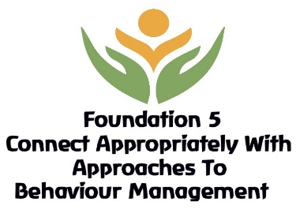
Connecting and belonging drives the school approach to supporting attendance. All staff are supported to understand 'deeper roots' regarding poor attendance concerns. The school has developed, and embedded, an effective rewards system to further drive attendance improvements and celebrate success.
DFE: Working Together To Improve Attendance 2022.

From September 2022 the DFE: Working Together to Improve Attendance paper will replace all previous guidance on school attendance except for statutory guidance for parental responsibility measures. The Secretary of State has committed to it becoming statutory when parliamentary time allows (this will be no sooner than September 2023).
The table below identifies how the 5 Foundations of Effective Attendance Practice will underpin the DFE 2022 paper.
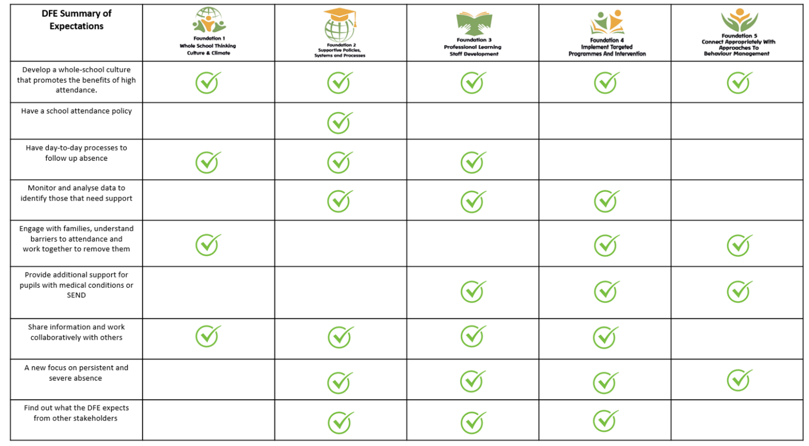

Much Marcle CE Primary School will always work in partnership with our parents
Much Marcle CE Primary School recognises that poor attendance is often an indication of difficulties in a child’s life and their lived experience. This may be related to problems at home or in school. Parents should inform the school of any difficulties or changes in circumstances that may affect their child’s attendance and or behaviour in school, for example, bereavement, divorce/separation, incidents of domestic abuse. This will help the school to identify any additional early help that may be required. Safeguarding is a priority, concerns for any child at any time will be reported to the Designated Safeguarding Lead – Laura Davies. We will always follow Keeping Children Safe in Education 2022 and our Child Protection Policy.
Some children are more likely to require additional support to attain good attendance, for example, children who are vulnerable, have a medical need or EHCP plan will be monitored and supported in school. At Much Marcle we will proactively identify and follow up on a child’s non-attendance and gather information about the child. This will result in taking early action to prevent non-attendance developing and monitoring the impact of targeted support.
The Head Teacher will initially:
- Check records, including any from other schools which the child has attended previously.
- Discuss with staff how the child is coping with the curriculum
- Review any Special Educational Needs that may have an impact
- Take into account the voice of the child and understand any difficulties, e.g. curriculum or bullying and their views on the issue could be addressed.

Children whose attendance falls below 90% are Persistently Absent from school, where a child falls under 50% attendance the child will be classified as a Severely Absent child. Persistently Absent from school equates to missing 19 days in total, across the academic year. Ultimately this will indicate that all intervention, and support, offered by Much Marcle CE Primary School has not made the expected impact to improve overall attendance. Where attendance remains a concern and all other interventions and support have not made a significant impact, we will escalate with external partners.
Attendance Support Map
We will always support children during each stage of our Attendance Support Map. If there is lack of engagement, or concerns regarding the reason for absence, we will follow the Attendance Map to ensure we prioritise a child’s learning and right to education.

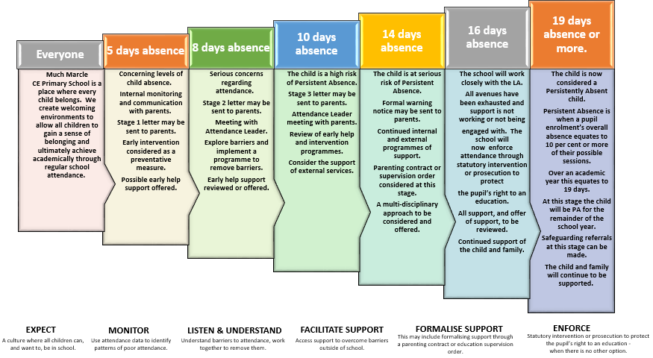

Much Marcle Day Contact
At Much Marcle CE Primary School we expect our parents to make contact at the earliest opportunity on the first day of any absence. We will always contact you via text message or by calling you. Where we have on-going concerns regarding your child’s attendance, we will visit your home address and write to you. We may even invite you to meet with a member of staff to discuss any on-going concerns regarding attendance. It is important that you talk to us first; you are legally responsible under Education Act 1996 for ensuring that your child is in school every day and on time. If we cannot make contact with you, we will continue to make announced and unannounced home visits, regarding any concerns we may have surrounding attendance at Much Marcle CE Primary School.

Parents are responsible for securing full-time education
Parents are responsible for ensuring their children receive a full-time education. Each situation will be dealt with on an individual basis, fairly and equitably always remembering the welfare and safety of the child is the paramount concern.
The term ‘parent’ includes those who are not a natural parent but have parental responsibility for the child as defined by the Children’s Act 1989 or have care of the child as defined by the Education Act 1996.
- Absence can only be authorised by the school; parents do not have this authority. All absences will be treated as unauthorised unless satisfactory evidence for the child’s absence has been received. In the first instance contact from the parent will be accepted as evidence. However, if a child’s attendance continues to cause concern, parents may be asked to provide medical evidence where absences occur repeatedly due to reported illness. This will usually be in the form of an appointment card, prescriptions etc. Absence may be coded as unauthorised without evidence.
- Parents should wherever possible make all medical and dental appointments outside of the school day. Where this is not possible, children should attend school for part of the day. Appointment cards should always be provided as evidence of medical/dental appointments.
- Unless parents have provided a satisfactory explanation and it has been accepted by the school absence will not be authorised.
Examples of unsatisfactory explanations include:
- A child’s/family member’s birthday.
- Shopping for uniform.
- Having their hair cut.
- Closure of a sibling’s school for INSET or other purposes.
- “Couldn’t get up”.
- Illness where the child is considered well enough to attend school without medical authority and in the absence of a communicable disease.
- Leave during term time taken without authorisation of the school
- Head lice – let the school know and letters will then be sent to all parents in a confidential manner.

Punctuality
Gates open for children at 08:45am, the class register will close at 09:00 am. Children arriving after the close of registration will be recorded as late. Late marks will not be authorised and will count as an absence for the school AM session. Punctuality is recorded and this will be added to your child’s record of attendance, a letter will be sent to parents every half term regarding attendance concerns of a child. If a child arrives at school from 09:15am they will be L Coded. If you child is late please report to the front office to sign them in.
The absence will only be authorised if a satisfactory explanation for the late arrival can be provided, for example, attendance at a medical appointment.
The absence will be recorded as unauthorised if a child has arrived late without justifiable cause, for example they woke up late or were waiting for their uniform to dry.
Transition following long term absence or illness
Absence can significantly interrupt the continuity of children’s learning.

During any long-term absence, Much Marcle CE Primary School will:
- Maintain contact with the child.
- Carefully plan the transition back to school, ensuring your child feels welcome and gains a sense of belonging.
- Ensure the child once again feels safe in school and if they experience any concerns, they will have an appointed member of staff to work with.
- The Class Teacher and Teaching Assistant will support a child when returning to class and help them with any work they may have missed.

Leave during Term Time
From 1st September 2013, the Government amended the England (Pupil Registration) (England) Regulations 2006. Head teachers may only grant leave in ‘exceptional circumstances’.
Parents wishing to apply for leave during term time must send a written request for the attention of the Headteacher before making any arrangements. Retrospective requests will not be considered and therefore will result in the absence being categorised as unauthorised. Each leave during term time request will be considered on an individual basis.

If a child fails to return and contact with the parent has not been made or received, school may take the child off the school’s roll in compliance with the Education (Pupil registration, England) Regulations 2006. This means that the child may lose their school place.
If the permission to take leave is not granted and the child is still absent from school, the absence will be unauthorised. In such cases the school may consider legal action.
Only in exceptional circumstances will absence be agreed. In such cases, consideration will be given to the cultural needs and the family circumstances, such as minority ethnic children returning to their country of origin. In these cases, granting leave for longer periods than normal may be considered justified. In all cases though, parents will be required to justify why the leave needs to be taken during term time.

Using attendance data
Children’s attendance will be monitored and shared with other agencies and the DfE.
Weekly attendance meetings will be held between the Head Teacher and Business Manager. Meetings will focus on agreed actions for those children of concern. The purpose of each meeting will be to understand the progress the school is making when supporting identified individuals or groups of children.
Attendance data will be used to identify emerging patterns and trends to inform whole school strategies to improve attendance and attainment.
It is the responsibility of school Governors to challenge and support the school regarding overall attendance, regular reports will be presented to this body. The governors will therefore examine closely the information provided for them and seek to ensure that our attendance figures are as high as can be.

Persistent Absence
At Much Marcle we aim to communicate the importance of attendance with parents and children. We have a particular focus on reducing Persistent Absenteeism at the school. The Persistent Absence threshold for children is currently 10% and Ofsted will use this threshold in its inspection of schools.
The threshold means that any child will be classed as Persistently Absent when they have missed 38 or more sessions. This equates to 19, or more, missed days during the academic year - which is as little as 6 days over each of the three Terms. This also equates to the equivalent of 1 day of absence, or more, a fortnight across a full school year
We will use a 19-day tracking system to make you aware of the number of days your child has missed in education. This will allow us to work together to reduce the number of days and attempt to prevent your child from reaching this number.
Once a child has reached 38 sessions, or 19 days absence, they will be classified as Persistently Absent from school and we may have to report this to the Local Authority and follow external legal proceedings.

Statutory Duty
Section 7 of the Education Act 1996 states that the parent of every child of compulsory school age receive efficient full-time education suitable to their age, aptitude and ability and any special educational needs they may have, either by regular attendance at school or otherwise.
A child is of compulsory school age at the beginning of the term following their 5th birthday.
Under the Education Act 1996, the Local Authority has a statutory responsibility to ensure that parents secure education for children of compulsory school age and where necessary, use legal enforcement.
In accordance with the regulations regarding pupils’ attendance at school, Much Marcle CE Primary School keeps an attendance register on which at the beginning of each morning and afternoon session children are marked present or absent. The marks are electronically processed and stored on the school’s central administrative system Scholarpack. This information is shared with the Department for Education.

Legal Sanctions
There are several sanctions that school can take to address the issue of non-attendance. To try and identify the reason for absence we will always talk to you first to identify the reason for absence. Much Marcle will always ensure the escalated process map is followed, focusing on the support a child needs at each stage (please access on the school website). However, for lack of engagement in attendance support there are sanctions that will be followed:
Penalty Notices
Penalty Notices will be considered when:
- A child is absent from school for the purpose of a Leave of Absence in term time and the absence has not been authorised by the school.
- A child has accumulated at least ten sessions of unauthorised absence and further absence has occurred following written warning to improve
- Holiday during term-time when the school has not authorised the absence and the child has missed at least 10 sessions within a 13 week period
Penalty Notices will be used in accordance with Herefordshire Council. Please see guidance below:
Appendix E- Code of Practice for issuing fixed penalty notices v1.4 (herefordshire.gov.uk)
Prosecution
Where intervention through the school’s process fails to bring about an improvement in attendance, the local authority will be notified and legal proceedings in the Magistrates Court may be taken. The school will provide the Local Authority with evidence required for a prosecution under section 444/4441 (a) of the Education Act 1996 and will appear as a prosecution witness if required by the court. This is to ensure that parents realise their own responsibilities in ensuring their child’s attendance at school.
Section 4441(a) of the Education Act 1996 states that if a parent fails to ensure the regular school attendance of their child if he/she is a registered pupil at a school and is of compulsory school age, then they are guilty of an offence.
Schools and local authorities are expected to work together and make use of the full range of legal interventions rather than relying solely on fixed penalty notices or prosecution. It is for individual schools and local authorities to decide whether to use them in an individual case after considering the individual circumstances of a family. These are:
• Parenting contracts
• Education supervision orders
• Attendance prosecution
• Parenting orders
• Fixed penalty notices
Please refer to section 6 of the DFE Working together to improve school attendance 2022 for more information.

Children at risk of Missing in Education (CME)

Children Missing Education (CME) are a vulnerable group of children. All agencies who work with children have a duty to support the Local Authority in ensuring all children are safe and looked after appropriately.
CME includes those children who are missing (family whereabouts unknown), and are children who are registered on a school roll / alternative provision. This might be a child who is not at their last known address and either
- has not taken up an allocated school place as expected, or
- has 5 or more days of continuous absence from school without explanation, or
- left school suddenly and the destination is unknown

It is our responsibility as a school to work with the LA Education and Inclusion team, by making referrals.

Celebrating Success
At Much Marcle we feel it is important to reward children who have achieved good or improved attendance. We notify parents of our whole school attendance percentage in our newsletter and advise you when we have school attendance campaign weeks. The weekly 96% Attendance challenge allows classes to celebrate their collective attendance successes. This is displayed in the entrance to the school for all to see.
Much Marcle CE Primary School will always challenge falling attendance and reward improvements. We are committed to the future of all children that attend Much Marcle CE Primary School, and by working in partnership with the school community we believe that together we can achieve more!
We can only achieve this by working in partnership with you, if you have any concerns or anything that prevents your child from attending Much Marcle CE Primary School we will always be here to listen and help.

General Collection Procedures
General collection procedure Parents will promptly collect pupils at the end of the school day, which is 3.15pm (Nursery) and 3:20pm (rest of the school), from the front playground, inside the brick wall. Class Teachers typically take 10 minutes to dismiss their class of children. Dismissal starts at 3.15pm (Nursery) and 3.20pm (rest of school). Children collected after these times are deemed ‘late.’ Parents should be on-time to collect their children and not be late. Where there is a pattern of lateness, with parents being last to collect their children, school will remind these parents of school finish times and this Policy. For example, a parent regularly collecting their child at 3.35pm. If a child is not collected by this time they will be placed in afterschool club and charged.
Staff members supervise the playground until all pupils have been collected. Sufficient staff to pupil ratios will be met at all times during the collection process. Staff members will not release a pupil if it is felt that the parents are not in a fit state to ensure the pupil’s safety or if the pupil shows signs of distress or anxiety. In these cases, the school’s Child Protection and Safeguarding Policy will be followed and Children’s Social Care, and the Police if appropriate, will be contacted. Pupils will only be permitted to leave the premises with adults who are registered with the school as a person with collection responsibility. If the parent has arranged for someone else to collect their child, they will need to call the school office to make arrangements. The collecting person will need to know the password prior to collecting the child, and report to the office at home time with valid ID.

Other Policies supporting attendance.
Behaviour Policy
SEND Offer
Pupil Premium Statement.
Safeguarding and Child Protection Policy.
Roles and Responsibilities

Much Marcle expectations – Parents:
- Parents are legally responsible for ensuring their children attend the school regularly and may risk prosecution if they fail in this responsibility.
- Parents should ensure that their children arrive at school on time, with the correct equipment and in full school uniform.
- Parents should support the school by avoiding, if possible, non-emergency medical/dental appointments for their child during school time.
- Parents should be aware that they do not have the automatic right to take their child out of the school for a holiday during term time.
- It is the parents’ responsibility to inform the school of the reason for a child’s absence on the first day of absence and in line with the school’s procedures for informing of absence.
- All unexplained attendances will be monitored and parents will be kept informed about any attendance concerns relating to their own child. Parents are expected to attend meetings when requested and support the school in responding to ongoing attendance concerns.

Much Marcle expectations – Children:
- All children should aim to have an excellent attendance and punctuality record for which there will be appropriate rewards.
- All children are expected to be on the school site on time and ready to learn. Children are expected to be punctual to all lessons and registration.
- Children who arrive at school late must follow the correct procedures for recording their lateness and entering their lesson.
- Children who need to leave school for a medical appointment must follow the correct procedures for recording that they have permission to leave and have left the building.
- Children must not leave the school without permission, ‘truant’; this will be seen by the school as a Safeguarding concern as well as a Health and Safety concern.
Much Marcle expectations - Class Teacher
The Class Teacher are the key staff members in promoting regular punctual attendance. The Class Teacher will:
- provide a good example by always being punctual to registration and meeting children at the door – providing a welcoming environment;
- keep an accurate and up-to-date register of attendance;
- follow the Attendance Policy procedures when dealing with absences and punctuality;
- maintain swift action and effective communication with senior leaders on all attendance matters concerning their class;
- ensure that children and young people are aware of the importance of the school attendance target and their own individual attendance targets - where appropriate assist them in monitoring their own attendance rates;
- ensure children receive rewards in relation to attendance and punctuality success – aligned to the Attendance Policy:
- build a welcoming atmosphere in the classroom and provide support as necessary when children return after an absence.
Much Marcle expectations – Head Teacher and Business Manager.
The Head Teacher and Business Manager take responsibility for monitoring the attendance of children and regularly promote the importance of attendance and punctuality. They will:
- ensure that their team is aware of their responsibilities with respect to promoting attendance and punctuality and adherence to the attendance policy and procedures;
- ensure that rewards and sanctions for attendance and punctuality follow agreed procedures and align to the school’s Behaviour and Attendance Policy;
- monitor and track the attendance of vulnerable groups;
- monitor the attendance of individual classes, following up with irregular patterns of absenteeism that are not being effectively addressed;
- work together on ensuring that appropriate action is taken in the management of absenteeism and poor punctuality;
- have attendance as a regular item during staff meetings;
- ensure contact is made with parents of poor attendees – always placing support before sanction.

Much Marcle expectations – Head teacher
The Head Teacher is responsible for regularly checking attendance data and ensuring data is accurate and up to date. The Head Teacher will:
- ensure that data is input daily into the attendance management system;
- ensure that parents of absent children are contacted where notification of absence has not been received;
- respond to any parent seeking support on attendance concerns;
- provide regular attendance and punctuality data for relevant staff and external agencies in line with the agreed procedures and timescales;
- be responsible for keeping a record of the interventions in place to encourage attendance and for generating all documentation including letters to parents;
- be responsible for liaising closely with the Local Authority’s Attendance Team to ensure appropriate levels of intervention take place; referrals are made, and attendance meetings are set up;
- be responsible for managing and maintaining attendance records and systems.

Relevant legislation
The Education Act 1996
The Children Act 1989
The Crime and Disorder Act 1998
The Anti-social Behaviour Act 2003
The Education and Inspections Act 2006
The Sentencing Act 2020 The Education (Pupil Registration) (England) Regulations 2006
The Education (Parenting Contracts and Parenting Orders) (England) Regulations 2007
The Education (Penalty Notices) (England) Regulations 2007

Relevant government guidance
Parental responsibility measures for attendance and behaviour
Children missing education
Keeping children safe in education 2025
Working together to safeguard children
Elective home education
Alternative provision: statutory guidance for local authorities
Exclusion from maintained schools, academies and pupil referral units in England
Supporting pupils at school with medical conditions
Ensuring a good education for children who cannot attend school because of health needs
Promoting and supporting mental health and wellbeing in schools and colleges
Approaches to preventing and tackling bullying

