Early Years Nutrition Policy

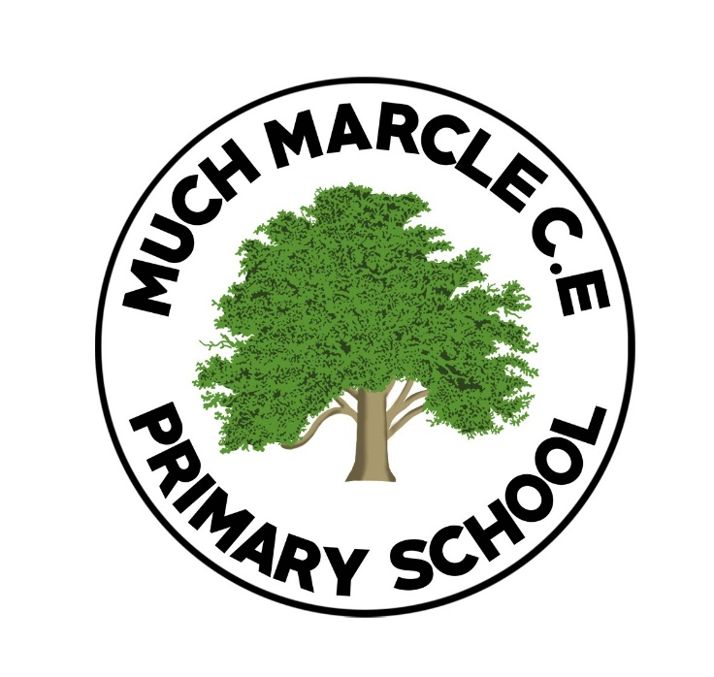

Approved by: | Laura Davies and Hannah Stratton
Last reviewed on: | Sept 2026
Next review due by: | Sept 2027

- Statement of Intent

1.1 Much Marcle CE Primary School and Nursery understands the importance of providing a healthy and balanced diet.

1.2 Pupils require the right amount of nutrients and energy they need while they are growing rapidly, this is particularly paramount for those children who are not offered the correct balanced diet at home.

1.3 All staff at Much Marcle CE Primary School and Nursery ensure that they teach children the importance of healthy eating and are providing children with the opportunity for positive eating habits. As stated in the EYFS Nutrition guidance “Children’s early experiences with food can shape future eating habits”.

1.4 The School and Nursery are committed to providing a nutritious and balanced diet through:
- Having children eating together in the setting to encourage children to try different foods that some children may not have tried before.
- Members of staff supervising children eating at all times.
- Ensuring allergies are catered for and all staff are aware of these allergies
- A healthy and balanced meal will be planned and offered to children at lunch time Parents will be able to order the meal through ‘School Money’ and therefore, they are aware of the menu that their child will be served
- Water will be available to children throughout the school day as well as fresh milk
- All staff working with children when they are eating will be paediatric first aid trained.
- All staff working with children who serve food will have the relevant Food Safety training in place
- If food is brought in from home (packed lunch)- parents are to consider healthy packed lunch choices – providing healthy, balanced and nutritious food

- Legal Framework

2.1 This policy has due regard to the relevant legislation, including, but not limited to, the following:
- Equality Act 2010
- Safeguarding Vulnerable Groups Act 2006
- Childcare Act 2006
- Education Act 2002
- Education Act 2011
- The Control of Substances Hazardous to Health Regulations 2002 (as amended in 2004)
- Early Years Foundation Stage nutrition guidance 2025
- EYFS Framework 2024

2.2 This policy has due regard to the relevant statutory guidance, including, but not limited to, the following:
- Early Years Foundation Stage nutrition guidance 2025

- What is nutrition guidance? (Please refer to Appendix 1)

3.1 The guidance states that: “Where children are provided with meals, snacks and drinks, these
must be healthy, balanced and nutritious”.

  - Nutrition Guidance includes the following:

- Ensure school meals are a balanced diet covering the 4 main food groups
- Ensure packed lunches brought in from home are healthy
- Allergies are catered for and plans in place where necessary
- Food for religious faith and beliefs and special dietary requirements are catered for
- Schools are to only allow children to drink water or semi-skimmed milk- avoid juice or sugary drinks
- Children should eat a variety of fruit and vegetables- this will be offered each day at snack time.

- Roles and Responsibilities

4.1 The headteacher is responsible:
- To ensure the catering company is offering a healthy and balanced menu weekly throughout the term.
- To ensure water is to be offered to all children throughout the day
- To ensure that all staff working with children with food are paediatric first aid trained
- To ensure all staff who are handling food have ‘Food Safety’ training.

4.2 All members of staff working with children in EYFS:

- Always ensure food is cut up to a size that is right for the child.
- Ensure parents/ carers are aware of the menu offered to children
- Members of staff have a positive relationship with parents and ensure that information is shared with families regarding a child’s food intake
- Monitor the food provided from home mostly aligns with the healthy options offered by our setting
- Packed lunches are checked to ensure the food is suitable and staff are preventing any choking
- Packed lunches can be kept at room temperature for 4 hours at a maximum- school cannot take any responsibility for the storage of food as there is no cooling facilities
- Any food that has been brought in from home such as; a birthday cake for a celebration must be checked of any allergens before serving to a child. Parents should then be told that their child has had something additional to their lunch time meal or fruit snack.

4.3 Parents are responsible for:
- Liaising with the school and nursery to communicate their wishes regarding their child’s dietary requirements
- Providing a healthy and balanced packed lunch and ensuring food is cut up appropriately
- Ensuring their child has a water bottle each day.

5. Implementation

Children’s packed lunches should include items from the 5 main food groups.
Bread, Rice, Potatoes, Pasta
These starchy foods are a healthy source of energy e.g., pasta salad, sandwiches, wraps, crackers.

Fruit and Vegetables
These foods provide vitamins, minerals and fibre. Lunches should include at least 1 portion of fruit and/or 1 portion of vegetables / salad, or more e.g., carrot/cucumber sticks, cherry tomatoes, a piece of fruit and including dried fruit.

Milk and Dairy foods
These foods provide calcium for healthy bones and teeth. Include 1 portion at lunch e.g., yoghurt, fromage frais, milk or cheese, custard or calcium-enriched plant based dairy alternative.

Meat, Fish, Eggs, Beans
These foods provide protein for growth. Packed lunches should include 1 portion of these foods e.g., egg, tuna, ham, cooked sausages, chicken, beans and pulses etc

Drinks – children are encouraged to drink water

Please see appendix 1 for a Parent Friendly Food Guide

Specific Items to consider
To ensure consistency and to keep packed lunches in line with food standards for school meals, packed lunches should not contain the following:
- Fizzy / sugary drinks in cartons, bottles or cans
- Sweets
- Chewing gum
- Energy drinks
- Caffeine drinks

6. Monitoring and Review

6.1 This policy will be reviewed annually by the headteacher and EYFS Lead, who will make any changes necessary and communicate these to all members of staff.

6.2 All members of staff specifically in the EYFS are required to familiarise themselves with this policy as part of their induction programme.

Appendix 1

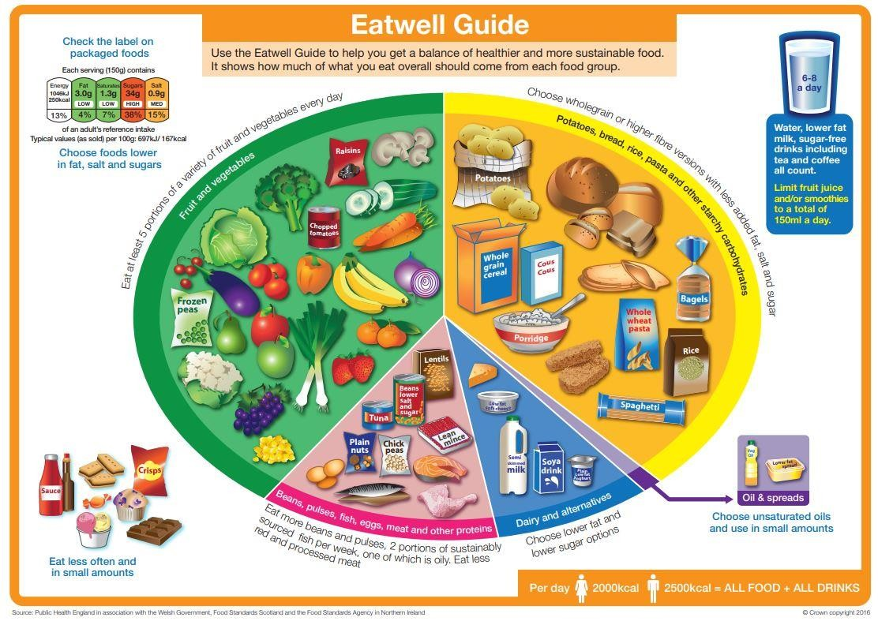

Appendix 2



