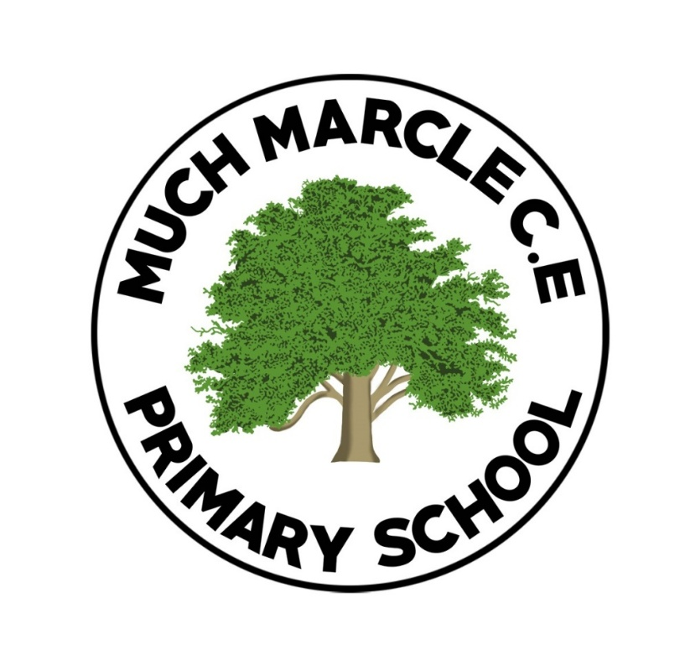
Religious Education Policy

Reviewed and Updated: September 2025

Date for Review: September 2028

This policy should be read in conjunction with the following school policies:
- Assessment Policy
- Marking and Feedback Policy
- Equalities Policy
- SEND Policy
- Homework Policy

What RE looks like at Much Marcle C of E Primary School.
As with all of our subjects, within the RE curriculum our drivers are at the heart of everything we do. Through our RE lessons we promote:
Our Curriculum Drivers
Perseverance | Confident Communicators | World Citizens | Healthy Body, Healthy Mind
Our curriculum drivers are integral to our curriculum. Our drivers ensure that pupils develop necessary qualities to succeed in all areas, ready for their next step in education and life.

As a Church of England school, our approach to Religious Education is rooted in our Christian vision inspired by the parable of the mustard seed (Matthew 13:31–32). This reminds us that even the smallest seed can grow into something strong and life-giving.
At Much Marcle C of E Primary School we believe that every child has the potential to grow, flourish and develop. Through Religious Education, pupils are encouraged to grow in knowledge, understanding, respect and compassion.
High quality Religious Education allows pupils to explore important questions about life, belief and meaning. It supports pupils in developing an understanding of Christianity as a living faith while learning about other religions and worldviews represented in modern Britain.
Intent – What are we trying to achieve?
A Religious Education curriculum which develops learning and results in the acquisition of knowledge and understanding of Christianity and other religions and worldviews, enabling children to enquire, reflect and develop their own understanding of belief and values.
Our intent for Religious Education is to support pupils in developing curiosity about faith, belief and the world around them. Through RE, pupils learn about religious traditions while reflecting on their own ideas and values.
The RE curriculum follows the Herefordshire Agreed Syllabus 2025–2030, ensuring pupils develop knowledge through the three key strands:
- Making sense of belief
- Making connections
- Understanding the impact
Our curriculum aims to:
Develop a secure understanding of Christianity as a living faith.
Enable pupils to learn about other major world religions and worldviews.
Encourage pupils to ask thoughtful questions about meaning, purpose and identity.
Promote respect, empathy and understanding for people with different beliefs.
Support pupils’ spiritual, moral, social and cultural development.
Prepare pupils to live well alongside others in a diverse society.
Through Religious Education we aim for pupils to grow in understanding and wisdom, just as the mustard seed grows into a strong tree.
What does Religious Education look like at Much Marcle?
Children will be encouraged to become curious learners through discussion, questioning and reflection about religion and belief.
A variety of approaches to teaching RE are used including:
- Storytelling and exploration of sacred texts
- Discussion and debate
- Creative activities such as art and drama
- Reflection and stillness
- Visitors from faith communities
- Visits to places of worship
Children will learn about Christianity in depth while also exploring other religions including Judaism, Islam, Hinduism, Sikhism and Buddhism.
By the end of EYFS pupils will have a secure foundation about the world around them including special people, celebrations and stories from different faiths.
By the end of KS1 pupils will develop an awareness of different religions and beliefs. They will begin to recognise that people have different ways of expressing belief and belonging.
Pupils will learn about important religious stories, celebrations and symbols and will begin to ask questions about meaning and belief.
By the end of KS2 pupils will develop a deeper understanding of religious beliefs, practices and traditions.
They will be able to:
- Describe similarities and differences between religions.
- Explain how beliefs influence how people live.
- Reflect on their own ideas and experiences.
- Discuss questions about meaning, purpose and morality.
- Children will develop the skills of enquiry, reflection, discussion and respectful dialogue.
Implementation – How is our vision translated into practice?
Our RE curriculum is based on the principles of knowing more and remembering more, ensuring pupils develop a secure understanding of religion and belief over time.
EYFS follows a one year rolling programme.
KS1 and KS2 follow a two-year rolling programme to ensure coverage, coherence and progression.
Christianity is taught in every year group alongside learning about other world religions.

How do we support our pupils?
We use assessment to identify any child who requires additional support.
Teachers provide careful scaffolding, pre-teaching and additional support where needed.
Children have knowledge organisers in their books and parents are informed of topic content through newsletters.

Spiritual Development Through RE
Religious Education plays an important role in supporting pupils’ spiritual development.
Our school vision based on the parable of the mustard seed reminds us that growth happens gradually through nurture, reflection and experience.
Through RE pupils are encouraged to:
Reflect on big questions about life and belief.
Develop a sense of awe and wonder.
Explore their own values and beliefs.
Show respect for people with different faiths and worldviews.
Understand their place within the wider world.
These experiences help pupils grow spiritually, just as a mustard seed grows into a strong and flourishing tree.
How RE contributes to the school’s Christian Character and Vision

Religious Education plays an important role in supporting the Christian character of Much Marcle C of E Primary School.
Through the RE curriculum pupils learn about the life and teachings of Jesus and explore the values that underpin our school community.
RE and collective worship complement one another.
Religious Education provides opportunities for academic learning about religion and belief.
Collective worship provides opportunities for spiritual reflection and shared experiences rooted in Christian tradition.
Together they support pupils in understanding the Christian ethos of the school while encouraging respect for people of all faiths and none.

Lesson Structure
Each lesson will follow a specific structure
- Explicit vocabulary teaching
- Flashback questions
- Teacher input – (using a range of resources from agreed schemes)
- Independent application
- Plenary
Teaching Strategies
- Ping Pong method
- My Turn Your Turn
- Reasoning embedded throughout
- All children work towards same learning objective with differing levels of support
- Stem sentences
- Learning partners
- Discussion and questioning
- Reflection activities
- Vocabulary development
- Use of artefacts and texts
Children are encouraged to listen carefully to each other’s ideas and respond respectfully.

Marking
Marking in RE follows the school’s Marking and Feedback Policy.

Assessment
Teachers assess pupils’ understanding through discussion, written work and reflection activities.
Assessment focuses on pupils’ ability to:
- Understand religious beliefs and practices
- Explain the impact of beliefs on people’s lives
- Reflect on their own ideas and experiences
Progress and attainment are shared with parents through parents’ evenings and end of year reports.
SEND Pupils
SEND pupils may be supported by additional adults, adapted resources or scaffolding.
All children work towards the same learning objective.
Some pupils may require additional support, extra time or pre-teaching.
We have high expectations for all pupils and believe all children can succeed when supported appropriately.

Challenge
All pupils work towards the same learning objective.
Higher ability pupils are challenged through deeper questioning, extended discussion and opportunities to explain and justify their thinking.

Impact – What is the impact of our curriculum?
Our pupils demonstrate enthusiasm for Religious Education and engage thoughtfully with questions about belief and values.
Pupils develop a rich vocabulary which enables them to discuss religion and belief with confidence.
Children are respectful of others’ beliefs and understand the diversity of faiths within society.
Children are reflective learners who can talk about their own ideas and values.
Teaching practices across the school support long-term knowledge retention.
Children develop curiosity about religion and belief and are prepared for further study at Key Stage 3.

Collective Worship
Collective worship is an important part of daily life at Much Marcle C of E Primary School and plays a key role in nurturing the spiritual development of our pupils and supporting the Christian character of the school. Worship takes place every morning and provides an opportunity for the whole school community to come together in reflection, prayer and celebration.
Collective worship is rooted in the teachings of Christianity and reflects our school vision inspired by the parable of the mustard seed (Matthew 13:31–32). Through worship, pupils are encouraged to reflect on Christian values, develop a sense of belonging, and grow spiritually, recognising that even small acts of kindness, courage and faith can lead to meaningful growth.
Worship takes a variety of forms throughout the week to ensure that pupils experience different ways of engaging with faith and reflection.
Each Friday, worship is led by representatives from Open the Book. These sessions bring Bible stories to life through engaging dramatisations, helping children to understand key stories and messages from the Bible in an accessible and memorable way.

Each Thursday, Class 4 pupils lead collective worship for the school. These services include dramatisations of Bible stories as well as child-written prayers created by the school’s Worship Ministry. The prayers are written in response to prayer requests from pupils across the school, enabling children to actively contribute to the spiritual life of the school community and reflect on issues that matter to them.
Across the week, collective worship includes elements such as:
- Bible stories and teachings
- Reflection and moments of stillness
- Prayer
- Singing and celebration
- Opportunities for pupil leadership
Collective worship complements the Religious Education curriculum by providing opportunities for spiritual reflection and shared experience, while RE lessons provide academic learning about religion and belief.
Through collective worship, pupils are encouraged to reflect on Christian teachings, consider their own beliefs and values, and develop respect and understanding for others. These experiences help nurture a school community where all members are supported to grow and flourish, just like the mustard seed growing into a strong and welcoming tree.

